**PROGRAM 3: SUPPLIER DATABASE**

Consider the following schema:

SUPPLIERS(sid: integer, sname: string, address: string)

PARTS(pid: integer, pname: string, color: string)

CATALOG(sid: integer, pid: integer, cost: real)

The Catalog relation lists the prices charged for parts by Suppliers.

Write the following queries in SQL:

• Find the pnames of parts for which there is some supplier.

• Find the snames of suppliers who supply every part.

• Find the snames of suppliers who supply every red part.

• Find the pnames of parts supplied by Acme Widget Suppliers and by no one else.

• Find the sids of suppliers who charge more for some part than the average cost of that

part (averaged over all the suppliers who supply that part).

• For each part, find the sname of the supplier who charges the most for that part.

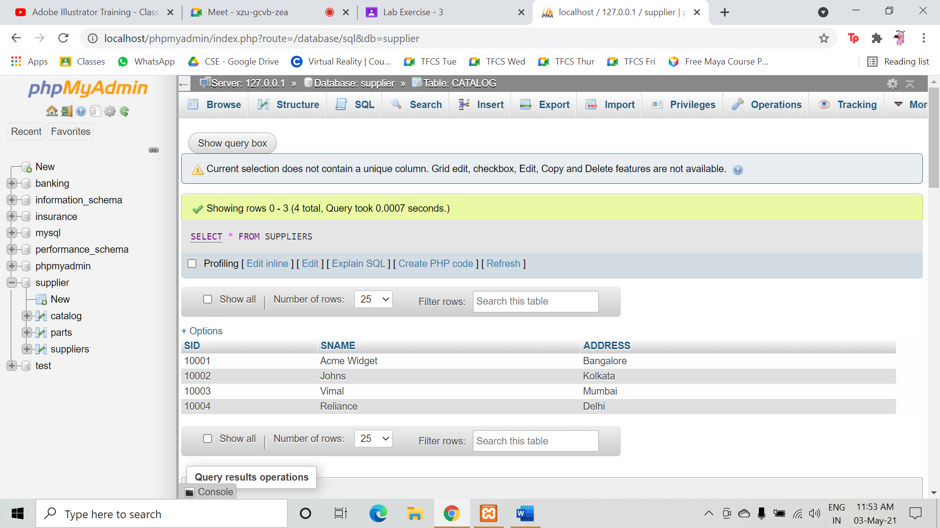

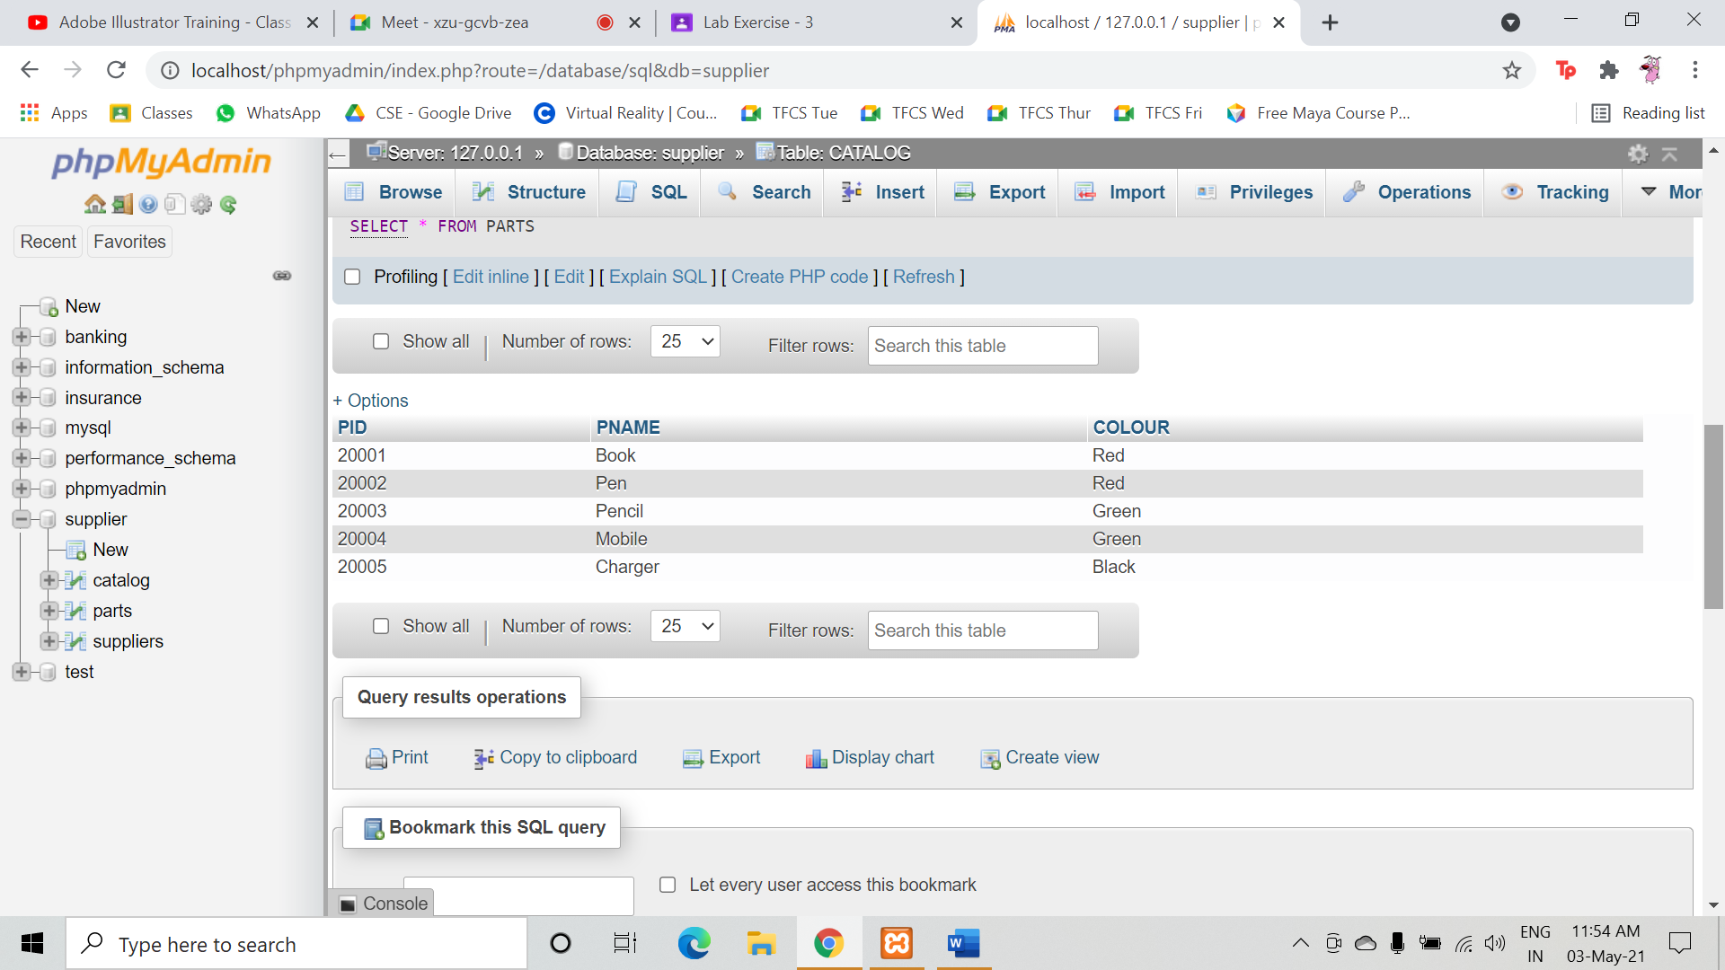

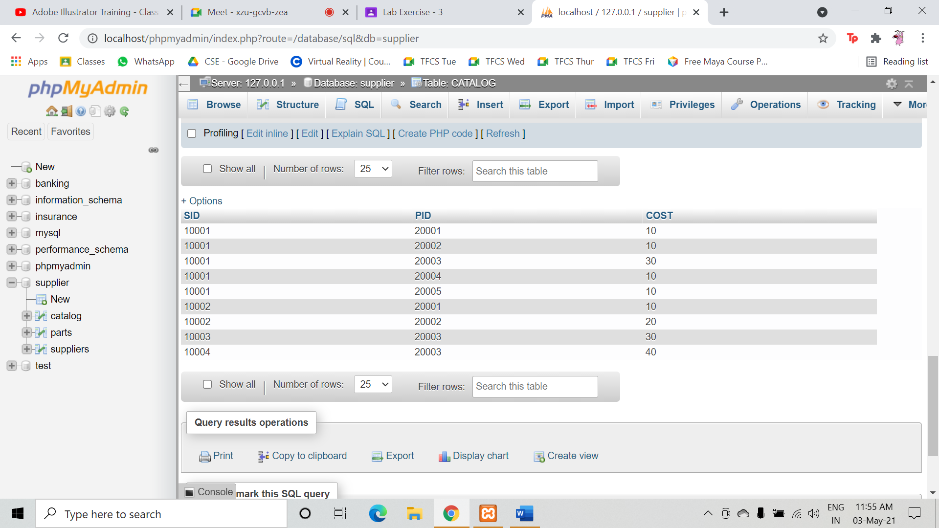

* Find the pnames of parts for which there is some supplier:

QUERY: SELECT PNAME FROM PARTS,CATALOG WHERE CATALOG.PID=PARTS.PID AND CATALOG.SID IS NOT NULL;

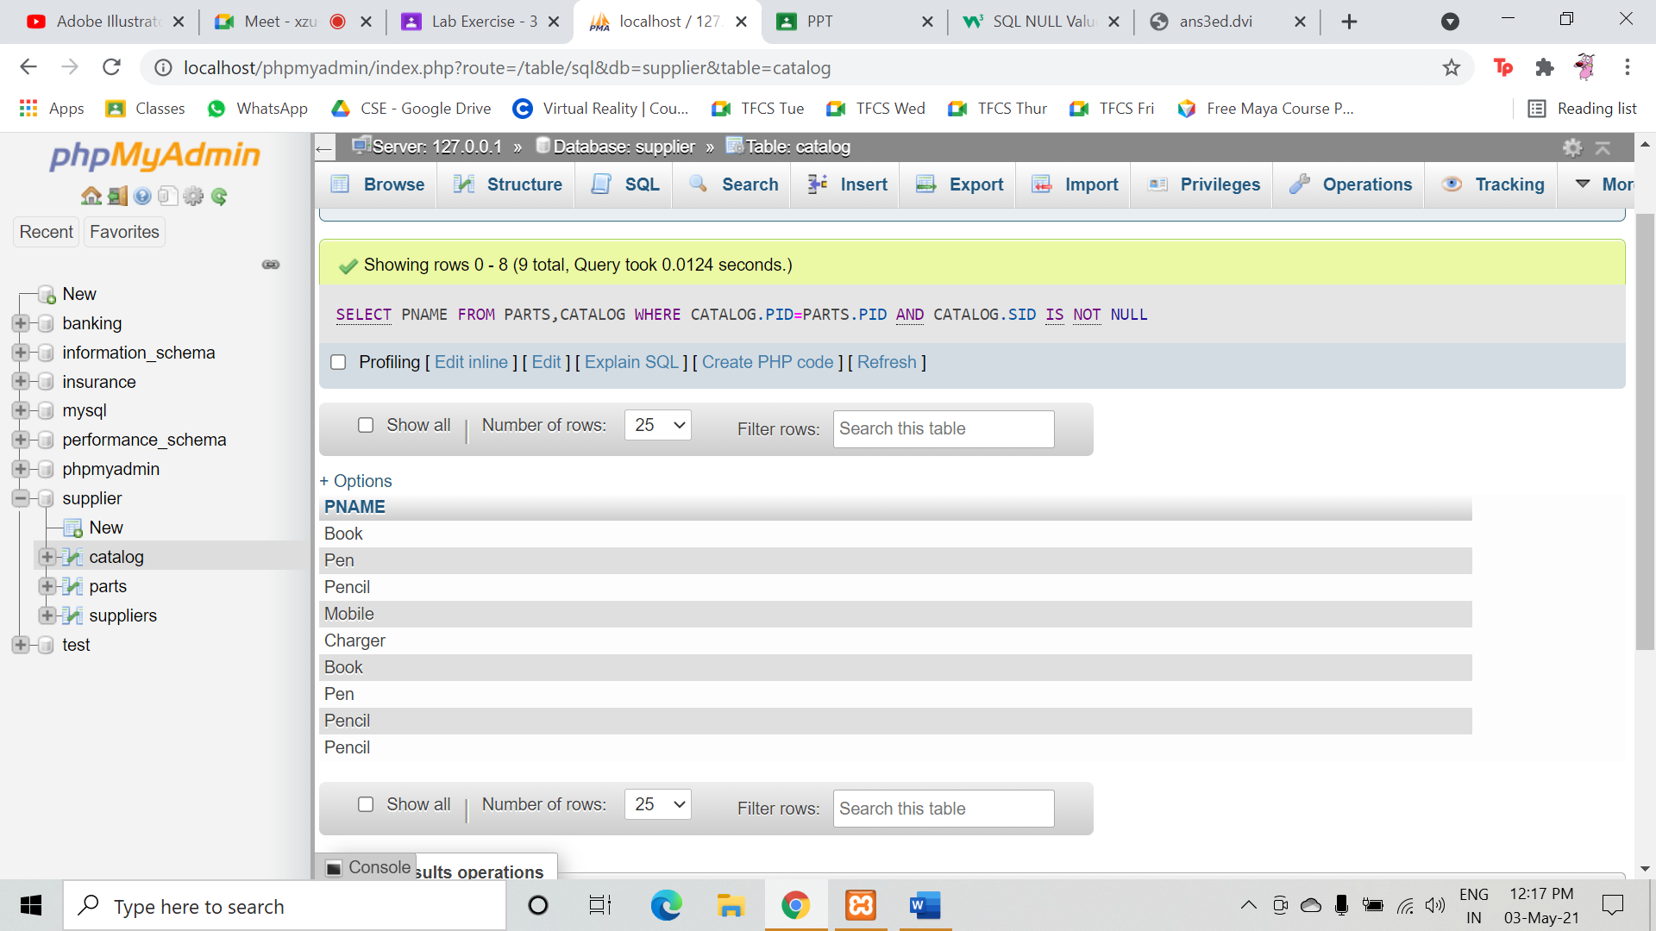

* Find the snames of suppliers who supply every part:

QUERY: SELECT S.SNAME FROM SUPPLIERS S WHERE NOT EXISTS((SELECT P.PID FROM PARTS P ) EXCEPT (SELECT C.PID FROM CATALOG C WHERE C.SID = S.SID));

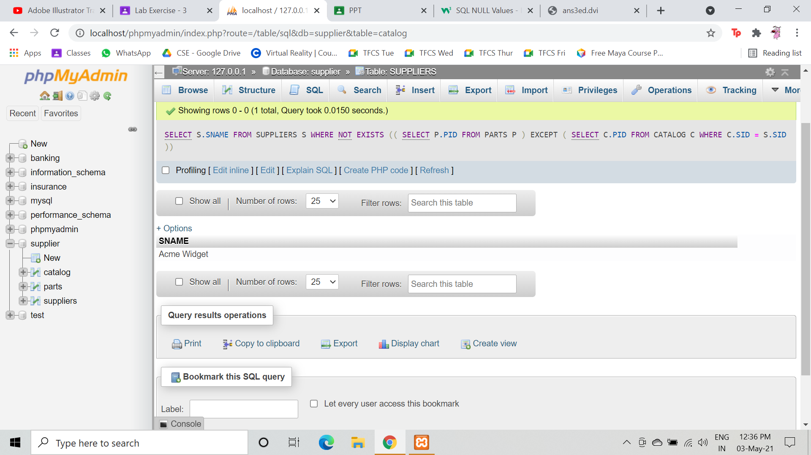

* Find the snames of suppliers who supply every red part.

QUERY: SELECT S.SNAME FROM SUPPLIERS S WHERE NOT EXISTS (( SELECT P.PID FROM PARTS P WHERE P.COLOUR = 'Red' ) EXCEPT ( SELECT C.PID FROM CATALOG C, PARTS P WHERE C.SID = S.SID AND C.PID = P.PID AND P.COLOUR = 'Red' ));

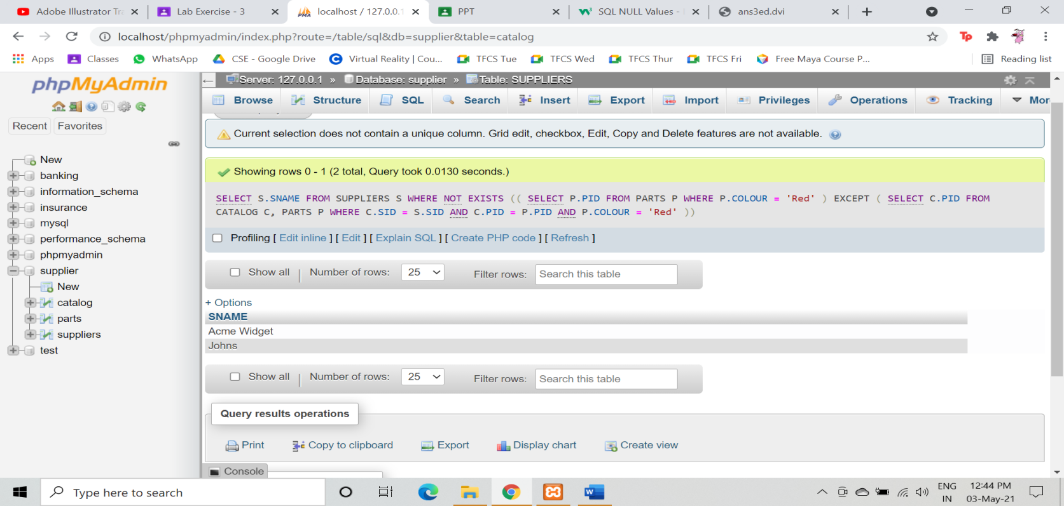

* Find the pnames of parts supplied by Acme Widget Suppliers and by no one else.

QUERY: SELECT P.PNAME FROM PARTS P, CATALOG C, SUPPLIERS S WHERE P.PID = C.PID AND C.SID = S.SID AND S.SNAME = 'Acme Widget' AND NOT EXISTS ( SELECT * FROM CATALOG C1, SUPPLIERS S1 WHERE P.PID = C1.PID AND C1.SID = S1.SID AND S1.SNAME<>'Acme Widget');

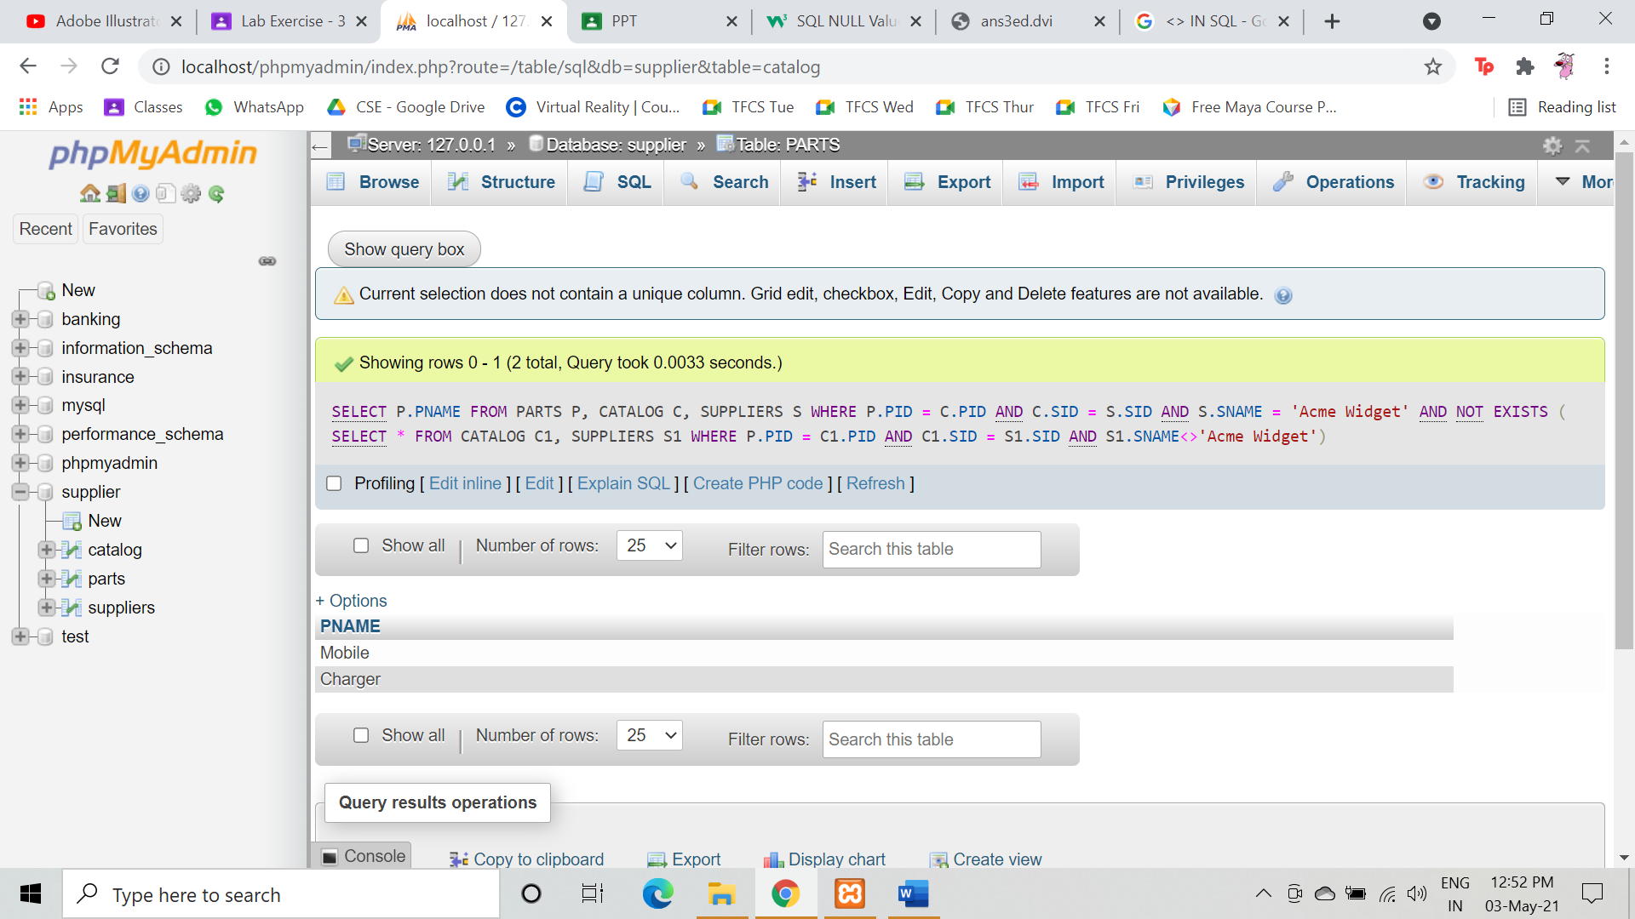

* Find the sids of suppliers who charge more for some part than the average cost of that

part (averaged over all the suppliers who supply that part).

QUERY: SELECT DISTINCT C.SID FROM CATALOG C WHERE C.COST > ( SELECT AVG (C1.COST) FROM CATALOG C1 WHERE C1.PID = C.PID );

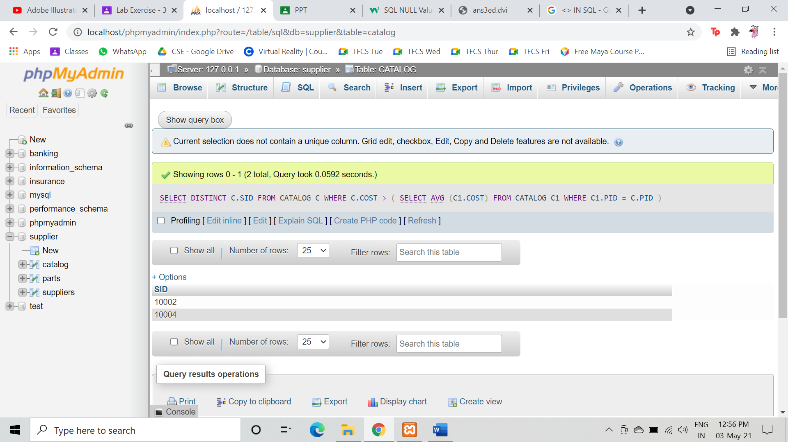

* For each part, find the sname of the supplier who charges the most for that part.

QUERY: SELECT P.PID, S.SNAME FROM PARTS P, SUPPLIERS S, CATALOG C WHERE C.PID = P.PID AND C.SID = S.SID AND C.COST = (SELECT MAX (C1.COST) FROM CATALOG C1 WHERE C1.PID = P.PID);

